HƯỚNG DẪN ÔN TẬP THI CUỐI KÌ 2
MÔN TIẾNG ANH (PT) – KHỐI 8
Năm học 2023 – 2024
A/ VOCABULARY: UNIT 5, 6 AND 7.
B/ WORD FAMILY:
UNIT 5
 | NOUN | VERB | ADJECTIVE | ADVERB
1 | adaptation | adapt | adaptable | adaptively
2 | destruction | destroy | destructive | destructively
3 | flexibility |  | flexible | flexibly
4 | health |  | healthy | healthily
5 | importance |  | important | importantly
6 | information | inform | informative | informatively
7 | intelligence |  | intelligent | intelligently
8 | introduction | introduce | introductory
9 | involvement | involve | involved | involvedly
10 | manipulation | manipulate | manipulative | manipulatively
11 | prediction | predict | predictive | predictively
12 | survival  survivor | survive | survivable
UNIT 6
13 | attendance | attend | attentive | attentively
14 | challenge | challenge | challenging | challengingly
15 | conclusion | conclude | conclusive | conclusively
16 | enrolment | enrol |  | -
17 | graduation | graduate | graduated | -
18 | history |  | historical/ historic | historically
19 | management | manage | manageable | manageably
20 | obedience | obey | obedient | obediently
21 | sociability |  | sociable | sociably
22 | performance/ performer | perform | performative | performatively
23 | success | succeed | successful | successfully
24 | exhibition | exhibit |  | -
25 | location | locate | located | -
26 | practice | practise | practical | practically
27 | passion |  | passionate | passionately
UNIT 7
28 | access | access | accessible | accessibly
29 | aim | aim | aimed | -
30 | benefit | benefit | beneficial | beneficially
31 | commerce | trade | commercial | commercially
32 | conservation  conservationist | conserve | conservative | conservatively
33 | donation/ donor | donate | - | -
34 | intention | Intend | intentional | intentionally
35 | ownership/ owner | own | own | -
36 | persuasion | persuade | persuasive | persuasively
37 | petition | petition | - | -
38 | proposal | propose | proposed | -
39 | protest/ protestant | protest | protestive
40 | rejection | reject | rejected | -
41 | signature | sign | signed | -
42 | support/ supporter | support | supportive | supportively
43 | volunteering  volunteer | volunteer | voluntary | -

B. Grammar and Structures:
- Past Simple  - Past Continuous  - Simple Past and Past Continuous with when, while  - Present Perfect  - Present Perfect Continuous  - Quantifiers: a few, a little, a lot of, enough, many, much  - Intensifiers: absolutely, really, very  - Object and Subject questions  - Reported Speech  - The first and second conditional | - Used to/ Didn’t use to  - Prepositions of time (on, at, in, every, …)  - Giving examples (for instance, for example, such as, like)  - Question tags  - Relative Clause  - Clauses of purpose (so that, to, in order to)  - Ordering information (Firstly, Secondly, Lastly/ Finally...)  - Expressing recommendations, opinions, purpose  - Building an argument

PRACTICE
A/ LISTENING:
PART A. Listen and decide if the statements are True or False.
1. The writer doesn’t believe that there are advantages to being kind. __________
2. Daniel Black and the boy both got the medical treatment they needed. __________
3. Receiving money changed Glen James’s life. __________
4. The rice ATMs distributed an unlimited amount of rice each time. __________

PART B. Listen to the tape again and choose the best answer A, B, C or D to complete each blank
1. _________, Hoang Tuan Anh invented a 24/7 automatic dispensing machine providing free rice for the poor.
A. in March 2021 B in April 2021 C. in March 2020 D. in April 2020
2. Daniel Black had an accident in ______
A. 2009 B. 2019 C. 2020 D. 2010
3. Daniel Black save ______________
A. $42,000 B. $ 160,000 C. $ 15,000 D. $ 22,000
4. __________ was unemployed and homeless.
A. Ethan Whittington B. Glen James C. Daniel Black D. Hoang Tuan Anh
Answers:
1. | 2. | 3. | 4.

B/ PRONUNCIATION:
PART 1: Which word has the underlined part pronounced differently from that of the others?
1. A. petition B. access C. else D. benefit
2. A. upon B. distribute C. support D. supply
3. A. career B. teenage C. degree D. week
4. A. unique B. unusual C. uniform D. university
5. A. alternative B. graffiti C. apprenticeship D. amazing
6. A. allow B. narrow C. owner D. lower
7. A. disadvantage B. panic C. timetable D. think
8. A. primary B. brilliant C. animal D. historic
9. A. comedy B. boycott C. gossip D. propose
10. A. attend B. enrol C. benefit D. upset

PART 2: Which word has a different stress pattern from that of the others?
1. A. preparation B. volunteer C. signature D. information
2. A. donate B. propose C. boycott D. amaze
3. A. enrol B. exam C. lesson D. obey
4. A. institution B. university C. entertainment D. journalism
5. A. flexible B. vehicle C. charity D. audition
6. A. epidemic B. catastrophe C. manipulate D. intelligent
7. A. activity B. incredible C. entrepreneur D. spontaneous
8. A. institution B. university C. entertainment D. journalism
9. A. secondary B. kindergarten C. ordinary D. curriculum
10. A. vegetable B. supermarket C. cyberbully D. entertainment

C/ MULTIPLE CHOICE: Choose the best answer (A, B, C or D)
1. If I ______ you, I would help to clean up Tàu Hủ canal.
A. was B. were C. am D. would be
2. She said that she ______ the petition online 3 years before.
A. would sign B. signed C. had been signed D. had signed
3. On the other ______, travelling abroad can be expensive for some.
A. hand B. arm C. finger D. elbow
4. Zara: “Tens of millions of sharks are hunted annually for their fins.” – Will: “Disgusting! ______”
A. I think it’s the best thing to do. B. I hope they introduce a law against it soon.
C. I’m not sure I agree with you. D. I like the idea of shark finning.
5. The ______ has caused a lot of disruption around the world.
A. proposal B. campaign C. support D. pandemic
6. If you ______ up early, you would have time to exercise before work.
A. woke B. wake C. will wake D. would wake
7. If I ______ a million dollars, I would travel around the world.
A. will have B. have C. had D. would have
8. Many people ______ against the company's decision to ______ plastic bags.
A. donate, access B. boycott, spread C. campaign, ban D. volunteer, aim
9. The ______ of the new policy is to improve public safety.
A. benefit B. signature C. aim D. support
10. She started a ______ to raise awareness about environmental issues.
A. protest B. spread C. petition D. volunteer
11. “I will meet you at the station tomorrow,” said Mary.
A. Mary says that she will meet me at the station tomorrow.
B. Mary said that she meets me at the station the following day.
C. Mary said that she would meet me at the station the next day.
D. Mary says that she met me at the station yesterday.
12. If they ______ harder, they would pass the exam.
A. will study B. studied C. study D. would study
13. I would like to ______ my time to help the local community.
A. reject B. spread C. volunteer D. access
14. In my opinion, students should wear a uniform to school. – “______”
A. I don't think uniforms are beautiful to wear.
B. What does that have to do with anything?
C. I will tell you tomorrow.
D. I agree, uniforms would promote equality and reduce bullying.
5. ______ is a form of street art that is often considered illegal.
A. Pop music B. Masked singer C. Petition D. Graffiti art
6. I'm ______ about my friend who hasn't replied to my message.
A. sociable B. upset C. challenging D. concerned
7. You ______ be 18 years old to vote in the United States.
A. can B. mustn't C. should D. must
8. You ______ always look both ways before crossing the street.
A. should B. need C. mustn't D. can
9. You ______ smoke in a hospital.
A. can B. should C. mustn't D. must
10. Sarah: “I have a job interview tomorrow.” - Tom: “______”
A. You must be worried about that trip. B. Why didn't you tell me about that person?
C. I think you should wear a funny outfit. D. Good luck! I hope it goes well.
11. The ______ building has been standing for over 100 years.
A. historic B. ordinary C. alternative D. unusual
12. Let me know when you come to Ha Noi and I'll ________.
A. take you out B. bring you around C. cheer you up D. show you around
13. I ______ speak three languages fluently.
A. should B. must C. mustn't D. can
14. If you don't ______ the rules, you may get into trouble.
A. cheat B. obey C. conclude D. upset
15. If I ______ my exam, I will be very happy.
A. fail B. sleep C. pass D. study
16. What will you be doing this time next year?
A. I will have graduated from university
B. I will have been graduated from university
C. I will graduate from university
D. I will be graduating from university
17. It's important to ______ to make sure you're healthy when you live alone.
A. look after yourself B. adopt C. have a family D. adapt
18. I need to ______ to live in a new country.
A. adapt B. manipulate C. process D. refuse
19. It's important to ______ when you're young so you can enjoy your retirement.
A. retire young B. earn money C. have a family D. get involved with a charity
10. What will you be doing at 7 pm tonight?
A. I will eat dinner B. I will have dinner
C. I will have eaten dinner D. I will be eating dinner
11. “Will you be available to attend the conference next week?”-”___________”
A. No, I don't have any free time to see a movie.
B. I'm not sure, I haven't checked my schedule yet.
C. No, I won't be home until 9 tonight.
D. Yes, I'll be at the beach for a whole week.
12. She has a lot of money in her ______.
A. bank account B. driving license C. pension D. degree
13. You should ______ when you're at a party.
A. settle down B. enjoy oneself C. tie down D. take up
14. If it ______ tomorrow, I will go to the beach and sunbathe.
A. rains B. snows C. is windy D. is hot
15. The National Safety Council has called for a blanket ban ______ the use of cell phones while driving.
A. on B. in C. for D. from
16. Residents should be fully informed of significant changes ______ the tax system.
A. to B. by C. with D. against
17. She led a campaign, which was held by WWF, for sea turtle ______ on Côn Đảo island.
A. reservation B. preservation C. conservation D. observation
18. An entrepreneur in Ho Chi Minh City has invented a ‘rice ATM’ to help those unable to work during the COVID-19 ______.
A. lockout B. lockjaw C. lockbox D. lockdown
19. I’ve signed a petition against ______. I think people should support victims more and campaign for change on social media.
A. cyberbullying B. verbal bullying C. anti-bullying D. indifferent bully
20. If I ______ his address, I could contact him.
A. know B. will know C. knew D. would know
21. What ______ you ______ if you had three wishes?
A. did / wish B. would / wish C. had / wished D. would have / wished
22. Tim told his father that he would clean the car ______ day.
A. the following B. following C. next D. the next to
23. “Are you Garfield?”, he asked.
A. He asked me if I was Garfield. B. He asked me if I were Garfield. C. He asked me weather I was Garfield. D. He asked me whether I were Garfield.
24. Scott: “______” – Blue: “You are right.”
A. What types of recycling people do every day? B. OK, I’ll answer your recycling questions. C. Don’t people already recycle? D. The main reason for recycling is to save the planet.
25. The government is ______ about the increasing number of traffic accidents.
A. hoping B. concerned C. concluding D. challenging
26. The man made a(n) ______ act by saving a baby who fell from 10th floor of an apartment.
A. heroic B. generous C. sympathetic D. honest
27. Having a spouse may increase your life ______ up to 15 years.
A. insurance B. experience C. expectancy D. lesson
28. They put up the tents and ______ for the night.
A. settled down B. started up C. tied down D. traveled around
29. Marcus gets involved ______ youth clubs and charity work.
A. to B. at C. on D. with
30. Despite ______ from the locals, the construction will proceed.
A. requires B. usages C. protests D. needs
31. “You’ll have to make up your mind soon.”, she said to me.
She told me I ______ make up my mind soon.
A. would have to B. had to C. could have to D. will have had to
32. During lockdown, Vietnamese people still had ______ to food and resources thanks to the effort of local government.
A. surgery B. action C. access D. benefit
33. Jimmy decided to reward ______ with a dinner out.
A. himself B. themselves C. yourself D. itself
34. Sean: “Don’t forget about the meeting this afternoon!” – Joe: “______”
A. I hope so. B. What time does it start?
C. I am telling you now. D. Can you help to book a taxi?
35. Is studying at home ______ easier than studying at school?
A. more B. too C. much D. a lot of
36. In the U.S, it’s difficult to find a job which not only is well-paid but also involves ______ people.
A. helping B. help C. to help D. helped
37. As exam season begins, parents and teachers will be looking for various ways to ______ students to do well in the studies.
A. concentrate B. motivate C. memorize D. surround
38. To get ______ college, you’ll need a high school diploma, good grades and scores from standardized tests such as SAT or ACT.
A. on B. in C. to D. into
39. Working in groups can help students learn from each other and become ______.
A. social B. socialized C. socialist D. sociable
40. After graduating from BRIT school, students are likely to have very successful careers ______ singers or actors.
A. as B. like C. either D. whether
41. People thought that only boys ______ go to school.
A. will be able to B. could C. have to D. must
42. Jasmine ______ apply for the job yet. She can do it later this week.
A. couldn’t B. doesn’t have to C. isn’t able to D. might not
43. You ______ be exhausted after a long trip. Come in and have a drink.
A. must B. can C. need D. should
44. Lona: “Don’t forget to do your homework.” – Dean: “______”
A. No problem. B. It’s crazy. C. OK, thanks. D. You’re welcome.
45. It’s very kind ______ you to help me with the housework.
A. of B. to C. on D. at
46. The project aims to provide the homeless in this area ______ food and assistance.
A. for B. in C. with D. by
47. Recycling needs a lot of work, but it’s definitely ______ the effort.
A. worthy B. worth C. worthwhile D. worthless
48. Proponents of PETA (People for the Ethical Treatment of Animals) have called for a ______ of products made from animal skins.
A. support B. boycott C. protest D. campaign
49. A surgery will be needed to ______ the boy to walk.
A. let B. make C. allow D. support
50. She was sitting ______ behind a big desk
A. importance B. important C. importantly D. importances
51. My new colleagues explained to me clearly and ______ how the process works.
A. inform B. informatively C. information D. informative
52. Most of the old part of the city was ______ by bombs during the war.
A. destroyed B. destruction C. destructive D. destructively
53. None of Shakespeare's plays ______ in its original manuscript form.
A. survival B. survivors C. survivable D. survives
54. Throughout her career she has very successfully ______ the media.
A. manipulated B. manipulation C. manipulative D. manipulatively
55. The ______ tell the story through song and dance.
A. performances B. perform C. performers D. performative
56. After ______, she wants to travel around Europe.
A. graduate B. graduated C. graduation D. graduates
57. The ______ of almost any project depends largely on its manager.
A. succeed B. success C. successful D. successfully
58. Did you leave his name out by accident or was it ______?
A. intention B. intentionally C. intend D. intentional
59. He's a very ______ dresser - he always looks like he's wearing his father's clothes!
A. conservative B. conservationist C. conservation D. conserve
60. The ______ future of the company looks very promising.
A. commerce B. commercial C. commercially D. commerces
Choose the word that has the CLOSEST meaning to the underlined word.
61. Keep in mind that Gen Z is a tech-savvy audience that’s unlike other ages.
A. formation B. times C. generations D. origination
62. Teaching as a profession is very underpaid.
A. work B. job C. cources D. procedure
63. I’d like to get involved with charity and spend more time abroad helping people.
A. develop B. finish C. engage in D. conclude
Error identification
64. If I (A) have more time, I (B)make (C) your birthday cake more (D) beautiful.
65. I (A) told them (B) that I (C) am (D) tired.
66. (A) Luggage (B) have to not (C) be left (D) unattended.
67. (A)If you (B) finishes your homework (C) early, you can (D) play video game.
68. If I (A) am Janet, I (B) would never forgive John (C) for what he (D) has done.
69. She (A) said she (B) loves (C) the Toy Story (D) films.
70. Daniel (A) said that he (B) worked (C) on (D) a bank.
Signs and posts

1. What will the music club be doing?  Music Club Notice:  Join music club! Meets Mon/Wed after school in auditorium. First meeting on Sept. 13th at 3:15 pm. Bring your instruments/voices! | A. Exploring different genres of music  B. Watching movies  C. Studying math  D. Playing sports after school
2. When does the science club meet?  Science Club Notice:  Science club opening soon! Meets Tues/Thurs after school in room 205. First meeting on Sept. 14th at 3:30 pm. | A. Saturday morning  B. Monday and Wednesday after school  C. Sunday afternoon  D. Tuesday and Thursday after school
3. What does this note say?  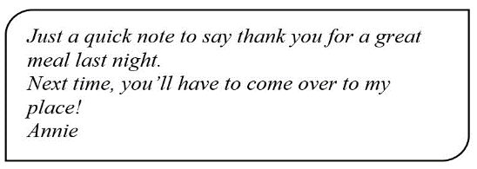 | A. Annie went to her friend’s house last night.  B. Annie invited her friend to her house last night.  C. Annie went to a restaurant last night.  D. Annie cooked a great meal last night.
4. What does the sign mean?  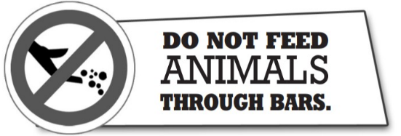 | A. Visitors should not get too close to the animals.  B. Visitors can feed animal here.  C. Visitors are a danger to the animals.  D. Visitors must not give food to the animals.
5. What does the message say?  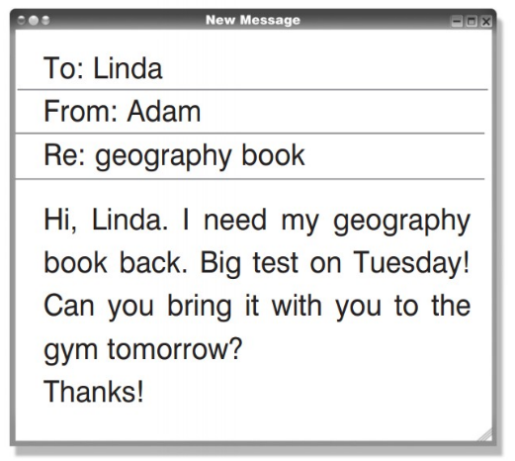 | A. On Tuesday, Adam has a geography exam.  B. Adam requests to take Linda's book.  C. The book belongs to Linda.  D. Linda wants to study in the fitness centre.
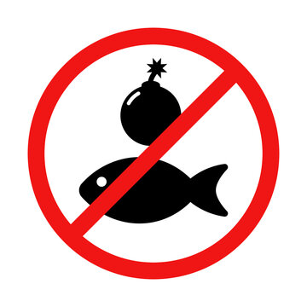  6. What does the sign mean? | A. You can go fishing in this river.  B. Stop using dynamite for fishing.  C. Deep water. Do not swim here.  D. Only use fresh ingredients for cooking.
7. What does the sign mean?  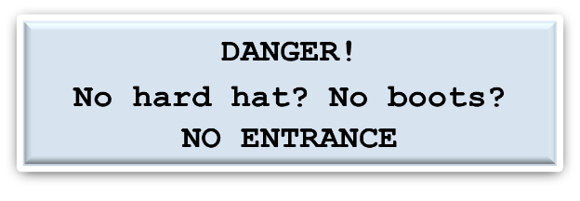 | A. Adults shouldn’t let children play with this.  B. Do not come in if you are wearing the right clothes.  C. You can buy protective clothing here.  D. Use this door to go outside.

8. What does the sign mean?  Wanted: Kitchen Assistants  Evenings or weekends  Free meals  Full training provided  Apply inside | A. Only people who are trained in kitchen work should apply for these part-time jobs.  B. There are part-time opportunities for people without experience of work in a kitchen.  C. We offer cheap meals to people who work part-time in our kitchen.  D. Part-time assistants must work both in the evenings and at weekends.
9. What does the sign mean?  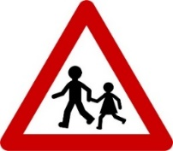 | A. Traffic lights.  B. No right turn.  C. Walking lane.  D. School ahead.
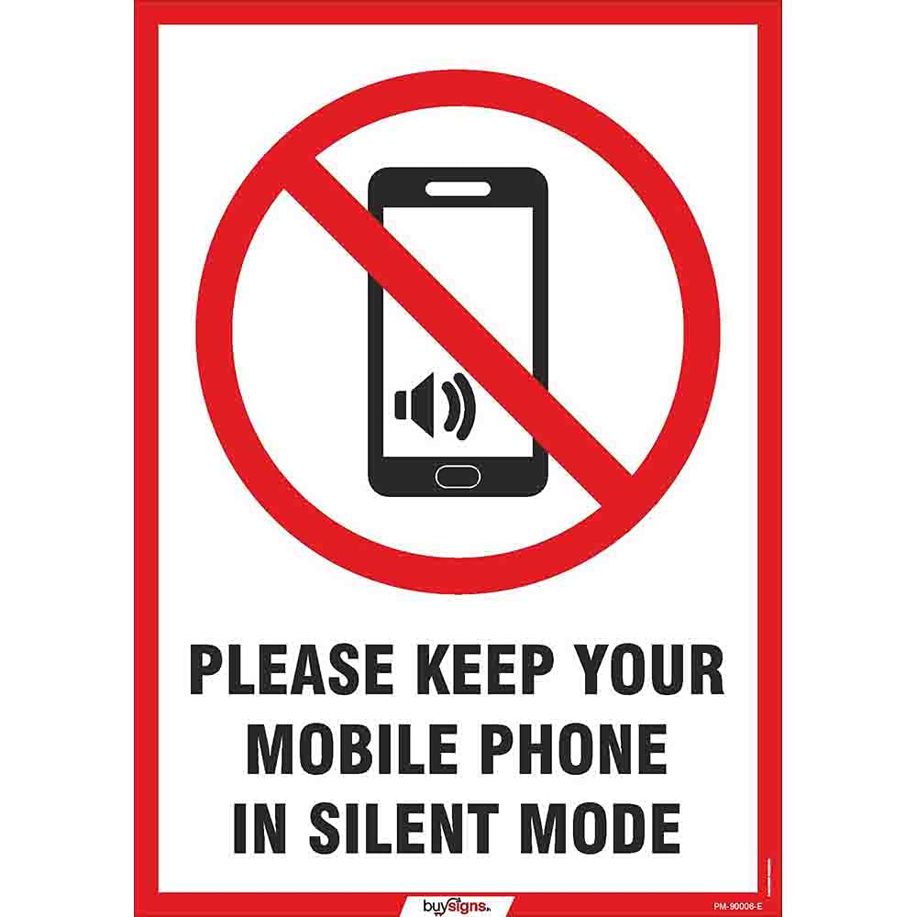  10. What does the sign mean? | A. Sit in your allocated seat.  B. Leave the chatter until the end of the movie.  C. Have awareness of personal space.  D. Keep your mobile phone in silent mode.

C/ READING:
Part A: Read the following text and decide whether the following statements are True or False
Passage 1
HUMAN CHANGES IN THE FUTURE
In the future, advancements in medical science may lead to significant changes in the human body. With ongoing research in fields such as genetics and biotechnology, it's possible that humans could have the ability to modify their physical attributes or even enhance their natural abilities. For instance, gene editing technologies might enable the correction of genetic disorders or the enhancement of desired traits. Additionally, advancements in prosthetics and bionic implants could provide individuals with enhanced mobility or sensory capabilities. However, while these developments hold promise for improving quality of life, they also raise ethical questions regarding the boundaries of human enhancement and the potential for creating unequal access to these technologies. Overall, the future of the human body may involve a blend of natural evolution and technological intervention, offering both opportunities and challenges for society to navigate.

- 1. According to the paragraph, advancements in medical science could lead to changes in the human body. (True/False)
- 2. The paragraph mentions that gene editing technologies could only be used for correcting genetic disorders. (True/False)
- 3. It is stated in the paragraph that advancements in prosthetics and bionic implants could not enhance mobility or sensory capabilities. (True/False)
- 4. The paragraph suggests that ethical questions might arise concerning the access to future medical technologies. (True/False)

Passage 2:
Careers and Teenagers
Choosing a career path is a significant decision for teenagers as it sets the foundation for their future. Teenagers often find themselves grappling with various options, trying to balance their interests, skills, and aspirations. Some may be drawn to traditional professions like medicine or engineering, while others may lean towards creative fields such as art or music. It's essential for teenagers to explore their options through internships, part-time jobs, or volunteer work to gain insights into different industries. Moreover, seeking guidance from mentors, career counselors, or family members can provide valuable advice and support. Additionally, with the advancement of technology, there's a plethora of new career paths emerging, such as data science, digital marketing, and artificial intelligence, offering teenagers exciting opportunities to explore innovative fields. Ultimately, teenagers should choose a career path that aligns with their passions and values, as it will lead to a more fulfilling and rewarding professional journey.

1 . Teenagers should only consider traditional professions like medicine or engineering. (True/False)
2. Internships and volunteer work are not helpful in exploring different career options. (True/False)
3. Seeking guidance from mentors or career counselors is unnecessary for teenagers. (True/False)
4. The advancement of technology has not resulted in the emergence of new career paths. (True/False)

Part B: Read the following text and choose the answer (A,B,C,or D) which fits best each blank
Passage 1:
In Viet Nam, it is not an easy task to become teachers assigned to far-flung mountainous areas. They must be patient and enthusiastic communicators. Most families in these regions are reluctant to (1) ______ time or money on their children’s education, especially girls, because of their poverty, distance to schools and (2) ______ beliefs that learning is unnecessary. The teachers have to pay these families a regular (3) ______ to persuade them to let their children keep going to school. Some teachers decide to learn ethnic dialects to facilitate their communication and persuasion. Teachers must be (4) ______ enough. In most cases, the teachers both deal with a mixed-level class of different grades and get involved with literacy classes for adults in the evenings. They have to find new teaching methods that help students with different learning abilities to study effectively. (5) ______ enthusiasm, patience and strong communication skills, teachers couldn’t keep teaching in remote areas and make a (6) ______ of difference to their students’ lives, impacting everything from their classroom learning to their long-term success.
1. A. expand B. extend C. expend D. exempt
2. A. deep-set B. deep-clean C. deep-rooted D. deep-frozen
3. A. call B. break C. visit D. interview
4. A. generous B. brave C. honest D. patient
5. A. But for B. With C. In addition D. However
6. A. world B. space C. room D. spell

Passage 2:
Do you believe that just a small act of kindness can change a person’s life? Joshua Coombes, a British hairdresser by (1) ______, has (2) ______ #DoSomethingForNothing to help homeless people regain their sense of identity. In 2015, while working at a hair salon, he decided to offer haircuts to down-and-outs free of (3) ______ and listened to their stories. He posted transformative images on social media to amplify the voices of those he met. These photos attracted public attention to those living (4) ______. Later, people with a variety of skills got involved in their own way with the same hashtag: yoga instructors volunteering in rehabilitation centers, students spending time with senior citizens who don’t have a family, neighbors helping (5) ______ with their shopping bags. Consequently, the movement has been featured in (6) ______ outlets around the world and was portrayed in a series released on Netflix internationally. Now, Coombes has been traveling to new countries in an effort to humanize the issue of homelessness globally and raise funds to help individuals that he meets.
1. A. hand B. means C. chance D. trade
2. A. invented B. initiated C. instituted D. initialized
3. A. time B. money C. charge D. use
4. A. long B. rough C. home D. out
5. A. one another B. each others C. every other D. one after another
6. A. media B. retail C. fast-food D. factory

THE ROYAL SCHOOL
Situated near the town of Windsor, Eton College is a full (1) ______ school where Prince William and Prince Harry used to study. Its prime purpose is to draw out the best of young people’s talents and to enable them to make good (2) ______ as happy, successful and socially responsible adults with all-round personality. In order to achieve this, the school puts a heavy emphasis on both academic results and extracurricular activities. In other words, pupils are encouraged to pursue excellence in all (3) ______ school subjects including art, drama, music and sports. They also have to participate in other community engagement programmes. Apart from actors and royals, this single-sex school (4) ______ scholarships to talented candidates from low-income families who wouldn’t (5) ______ be able to afford some or all of the tuition (6) ______. Approximately one-fifth of the boys receive financial aid. This helps nurture their dreams and develop their talents.
1. A. mixed B. boarding C. co-ed D. private
2. A. process B. proceed C. progress D. product
3. A. unlike B. unique C. differing D. dissimilar
4. A. gets B. gains C. grabs D. grants
5. A. otherwise B. in as much as C. therefore D. historically
6. A. fees B. fares C. fines D. cash

D/ WRITING: Complete the passage (80 words) based on the cue words
Passage A:
1/ Last weekend / my family / two day trip / home village./ We / start / the journey / early / morning.
2/ After three hours / travel / bus / we / reach / old banyan tree / entrance / the village.
3/ Everyone / feel tired / take a rest / the tree.
4/ After that / we start/ walk / the village / twenty minutes / come / my grandparents‘ house.
5/ We / spend / enjoyable weekend / the country./We / feel / happy and healthy/ the trip.

Passage B:
In Viet Nam, there are now 34 national parks. Con Dao National Park/ them. It/ national park in 1993. The park/ Con Dao District, Ba Ria-Vung Tau Province. It/ 16 small islands covering 20,000 hectares. The ecosystem here is very diverse with thousands / species, including marine animals. Many species of corals / sea turtles, dolphins, and / dugongs live here as well. The park is also home to a lot of valuable kinds of woods and medicinal plants. Three ancient trees in the park / “Vietnamese Heritage Trees”.

Passage C:
Is school the best place to learn?
There are many alternatives to school, such as homeschooling or studying online. But is school the best place for young people to learn?
In my opinion, it's better/ school for several reasons. Firstly, in school, students often have/ together, / they learn from each other and become sociable. Secondly, school students/ rules. This provides a structured day where students attend classes in a wide variety of subjects. They learn the importance of doing work on time and preparing for exams. This teaches them/ behave in society and future jobs. Finally, at school, students have the chance to / team sports and other projects that involve a group of people.
To conclude, students learn many things and in many ways / school. All in all, I think school is the / to learn.

PARAGRAPH D:
Secondary school students should wear casual clothes.
I think it is necessary for secondary school students to wear casual clothes/ they are at school.
Firstly, casual clothes make all students feel comfortable. They/ convenient clothes for outdoors and indoors activities. Secondly,/ can give students freedom/ choice. They can choose what sizes, colors, and fashions of clothing they love. Moreover, casual clothes can make students feel self-confident when they are in their favorite clothes/ they choose these clothes carefully and ensure them/ well-dressed. Finally, it makes the school more colorful and lively/ styles, colors and types of clothes.
In conclusion,/ opinion, all the secondary school students should wear casual clothes.

----------------GOOD LUCK ON YOUR TEST----------------

NHÓM TRƯỞNG ANH 8  Dương Nguyễn Thảo Linh | TỔ TRƯỞNG CHUYÊN MÔN  Trần Mai Trâm
DUYỆT CỦA BAN GIÁM HIỆU

